**Electronic Music**

Music in today’s society has gained significant relevance. Due to the rise of portable music players and recently smartphones music is available everywhere at any time. Electronic music is a relatively recent development, though many older people believe it not to match the definition of “music”.

Electronic music is defined as music which is digitally created but might be supplemented with

real instruments and vocals.



Source: Google pictures

**History of electronic music:**

It is older than many may think - the first electronic devices for music creation were developed at the end of the 19th century, and shortly afterwards Italians explored new sounds that had previously not been considered musical. During the 1920s and 1930s, electronic instruments were introduced and the first compositions for electronic instruments were made. At first electronic music was controversial and it took some time for it be accepted on a wide scale.

**Why some people still say that electronic music is „not really music“.**



Source: Google pictures

Many older people are used to the bands that create their music by playing traditional instruments only and by putting significant value on their voices. In fact, today’s electronic music has simpler structures making it less appealing to people who are used to more ‘complex’ music.

These people may well think that music created on the computer, for example, with mostly from pre-made sounds is not real music. First, at a concert, only the previously created music file will be played, and secondly, there will be no live effect, so that nothing can go wrong at a concert. That may be the opinion of many traditionally minded people. Of course, a majority of the younger generation is of another opinion.

The younger generation oftentimes only knows electronic music, at a technical school for example most teens will be well familiar with it. They may not even have been at a concert where a life band played their songs. One thing that elderly people may not know is that electronic music can also be created with real instruments. In fact, there are so many samples that were created with traditional instruments. So electronic music can also sound exactly like traditional instruments.

**Creating electronic music is a pretty good business!**

There are many producers who create electronic music. Some of these just do this for fun but there are of course business interests, too. Above all, a producer who creates music that appeals to people has to be able to market samples well and spread the music. Music producers use platforms such as [*youtube*](http://youtube.com/)and [*soundcloud*](http://soundcloud.com/) to promote their music and get followers.



DJs are people who play recorded music at a club or a party. The platform [*demodrop*](http://demodrop.com/) is for DJs who create music and want to share it with other people and for DJs who just want to download music for free for personal use.

Source: Google pictures

**BG Records**

Let me introduce an inhouse composer of e-music, Bernhard, who has a youtube channel that is open to the general public. (Channel: [*BG-Records*](https://www.youtube.com/channel/UCbl4OISKVDvcf60BaLEh06w/featured?disable_polymer=1)). Among the software used are daw-programs (digital audio workstation) like [*Logic Pro X*](https://itunes.apple.com/at/app/logic-pro-x/id634148309?mt=12) and [*Cubase*](https://www.steinberg.net/de/shop/buy_product/product/cubase-pro-10.html) to produce e-music. For you to start creating e-music you should have basic knowledge about the structure of a song and a sense of rhythm. There are a lot of good videos on the web that beginners may watch to learn how to create good e-music.

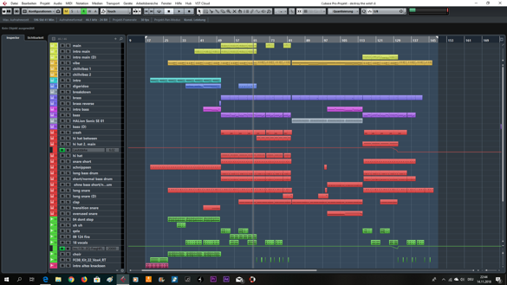

Source: Bernhard: a music project in Cubase

In summary you need both technical knowhow and creativity to create good e-music.